

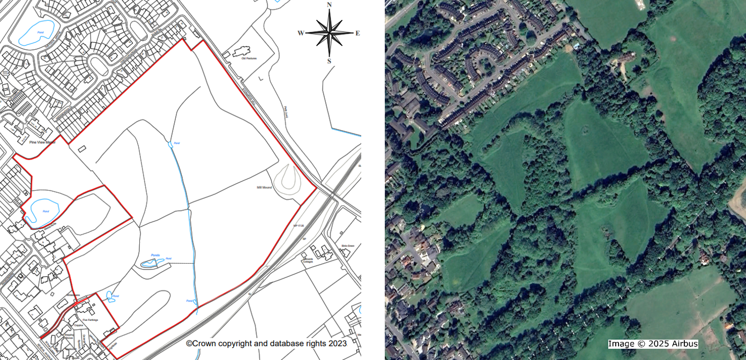**Asset of Community Value Evidence Form**

Land on the south west side of Stonards Hill, Epping

Epping Town Council is considering applying to Epping Forest District Council to designate an area of land to the south-west of Stonards Hill, shown edged in red, as an asset of community value.

To qualify for this designation the asset must have been used for the purposes of furthering the social well-being or the social interests of the local community.

This can take the form of cultural, recreational or sporting interests.

If you have made use of this area of land for any activities which might fall within these categories, we would invite you to complete and return the evidence form.

|  |  |  |
| --- | --- | --- |
| 1 | Have you used all or any part of this land for any cultural, recreational or sporting activities? If you have used only part of the land, please mark on theched plan the part which you have used. |  |
| 2 | For what purpose or purposes have you used the land? Please give specific details. |  |
| 3 | Over what period of time have you used the land? |  |
| 4 | How frequently have you used the land? Please be as specific as you can and try to avoid general expressions such as “frequently” or “regularly”. |  |
| 5 | Is your use of the land ongoing and likely to continue for the foreseeable future? |  |
| 6 | When using the land, where did you live? If in different places for different periods please give approximate dates. |  |
| 7 | Have you ever been given specific permission or consent to use the land? If so, by whom and to do what? |  |
| 8 | Have there been any barriers to entry to the land? If so, please describe these and mark their locations on the plan. |  |
| 9 | Have you ever been stopped from your use of the land? If so, please state where, when and by whom. |  |
| 10 | Have you seen other people using the land? If so, can you indicate numbers and summarise their activities. |  |
| 11 | What particular pleasure or enjoyment has this land given to you? |  |
| 12 | Do you have any other comments? |  |

Full Name of Witness: …………………………………………………………………………

Address: …………………………………………………………………………

…………………………………………………………………………

…………………………………………………………………………

Email: …………………………………………………………………………

Telephone Number: …………………………………………………………………………

